Closed Couplet

🎯 What is Closed Couplet
# Source: Chatgpt (GPT-4-turbo) at [8/2/2025]
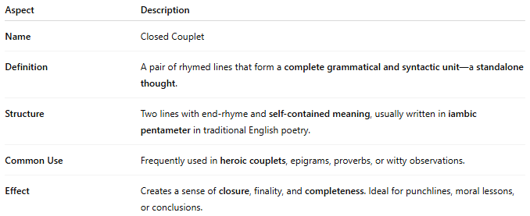
Aspect | Description
Name | Closed Couplet
Definition | A pair of rhymed lines that form a complete grammatical and syntactic unit—a standalone thought.
Structure | Two lines with end-rhyme and self-contained meaning, usually written in iambic pentameter in traditional English poetry.
Common Use | Frequently used in heroic couplets, epigrams, proverbs, or witty observations.
Effect | Creates a sense of closure, finality, and completeness. Ideal for punchlines, moral lessons, or conclusions.

✅ Example of a Closed Couplet
# Source: Chatgpt (GPT-4-turbo) at [8/2/2025]
True wit is nature to advantage dressed,
What oft was thought, but ne'er so well expressed.
— Alexander Pope
- Both lines rhyme (dressed / expressed).
- The thought is complete—you don't need the next lines to understand it.

🧠 Tip:
# Source: Chatgpt (GPT-4-turbo) at [8/2/2025]
- Contrast with an open couplet, where the sentence spills over into the next line or couplet.
- Often used in classical poetry for clarity and impact.

